**Github Repository** : <https://github.com/immanuelekoputro/testleaked>

**Functional Requirement for running this Project**

1. mysql database
2. Goland version > 1.20
3. Go migrate CLI

**Stack that used for this Project**

1. Golang
2. Mysql, my reason for using Mysql is my habit and more experiences using mysql as my database service, and mysql already have a good performace and have strong scalability, so it a good choice for application that have high transaction and handle big hardwork
3. Go Migrate, using Go migrate as database migration is a good option if we have a team and need a great versioning update for database, so all of changes of table should registered using go migrate to avoid different database structure for each team.

**ERD for Project**

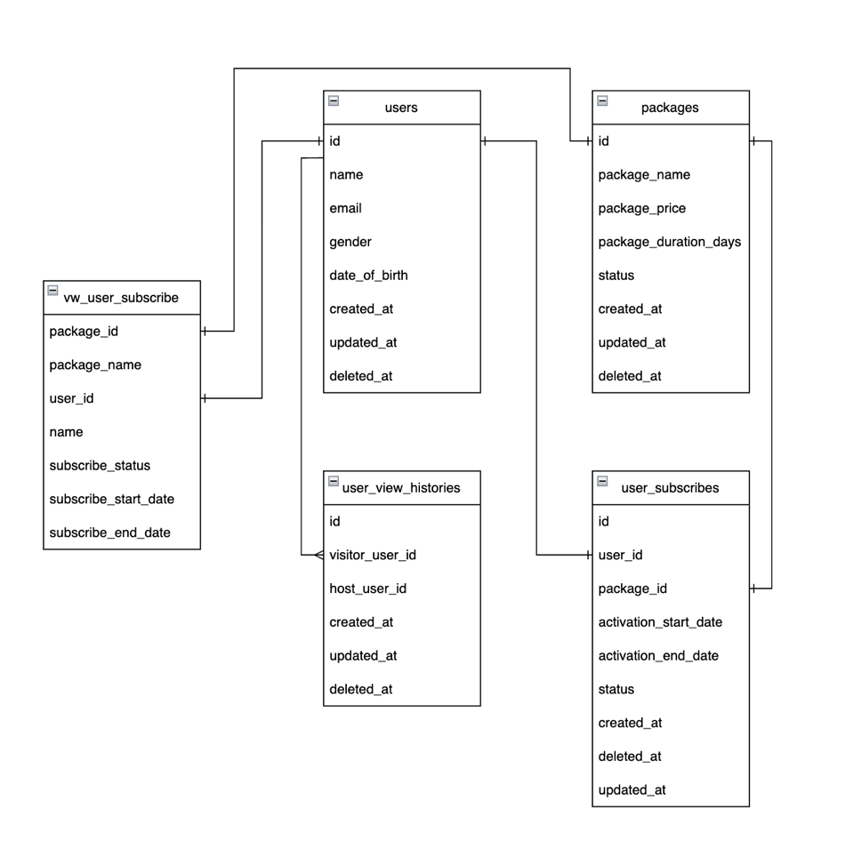

**Sequence Diagram Auth**

**Sequence Diagram Get Packages**

**Sequence Diagram Buy Packages**

